**Dynamic Functional Connectivity**

A tutorial

Lucas G. S. França[1]

Sunniva Fenn-Moltu[2]

Dafnis Batalle[3]

# 1 Introduction

This document was prepared on 2021-02-16.

# 2 Fig 1

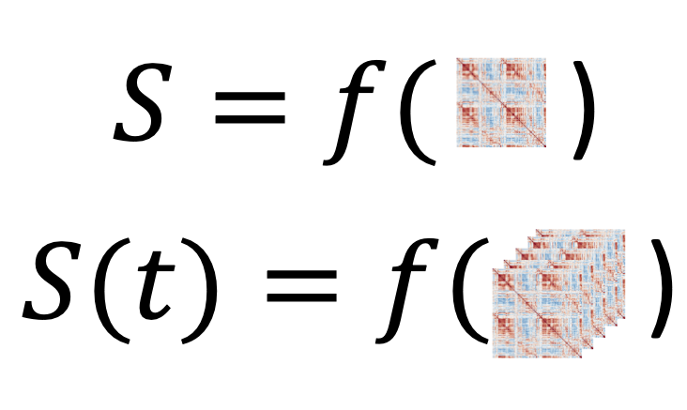

# 3 Fig 2



Adapted from: <https://en.wikipedia.org/wiki/Voxel#/media/File:Voxels.svg>

# 4 Fig 3



# 5 Fig 4

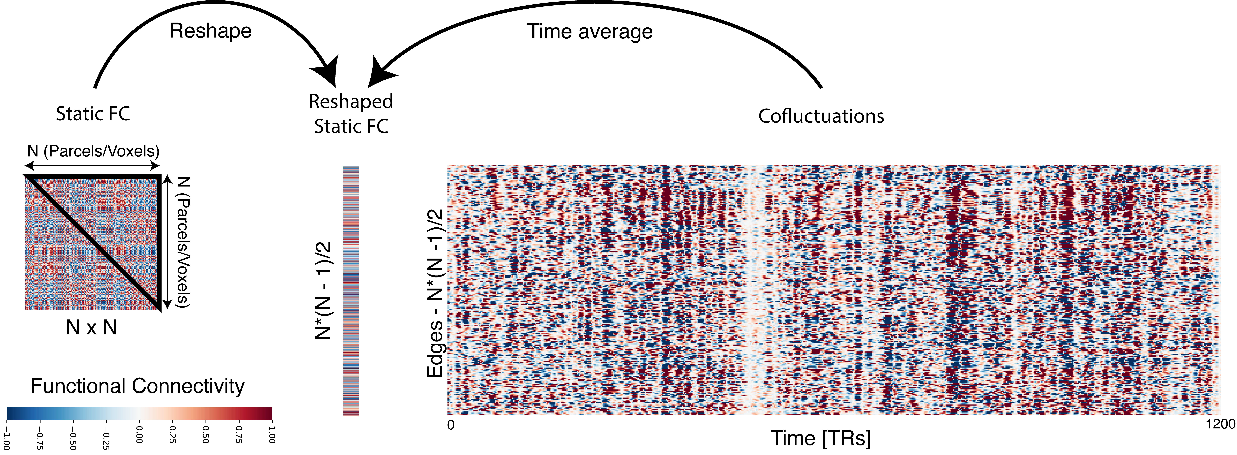

# 6 Fig 5



# 7 Fig 6

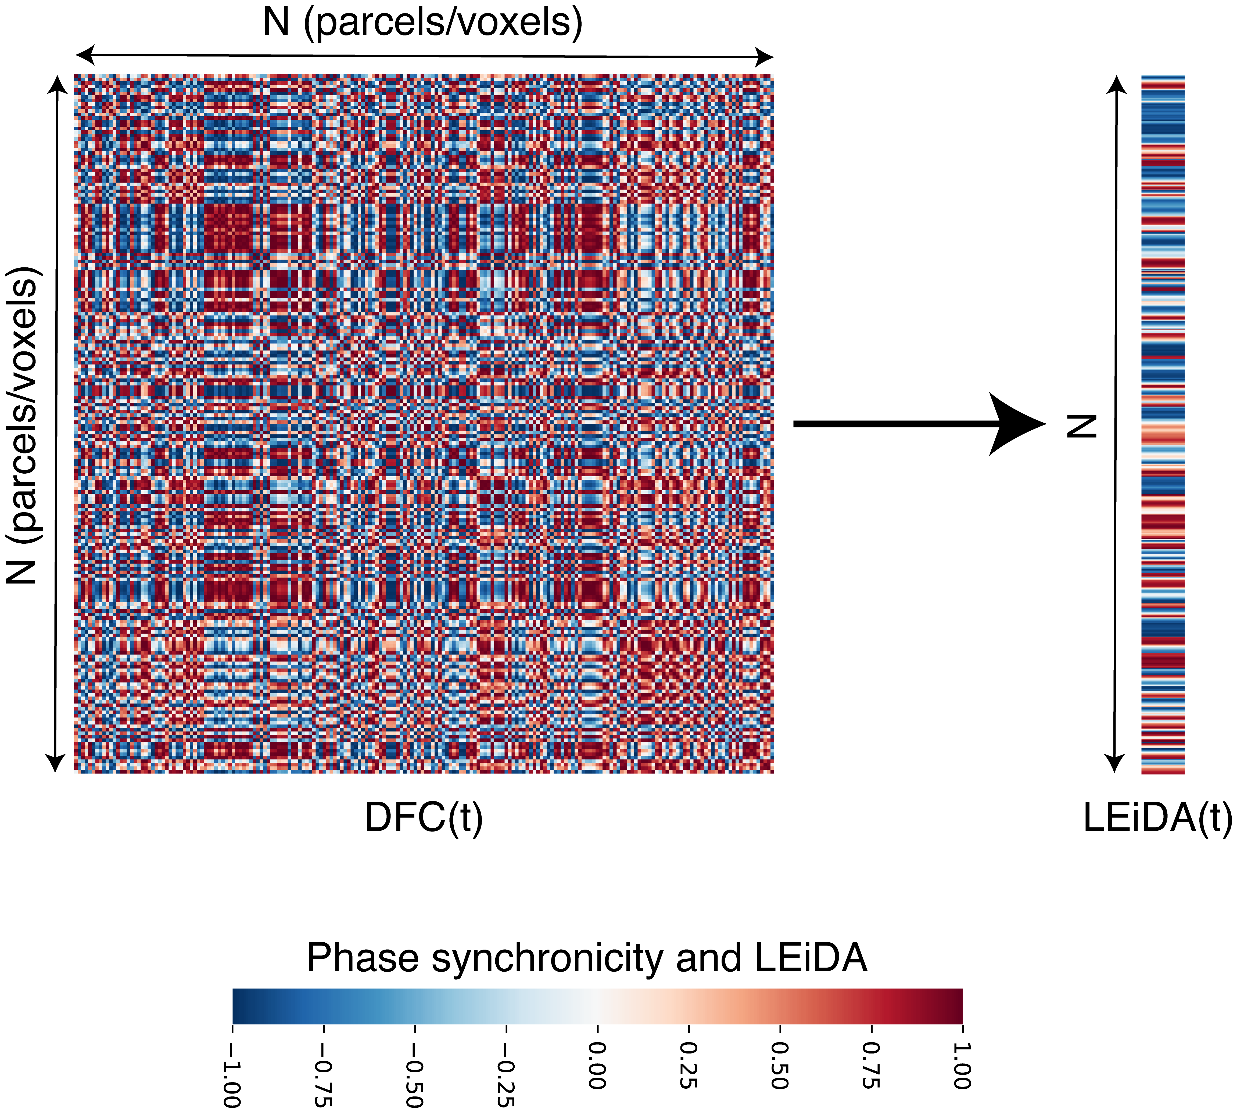

# 8 Fig 7

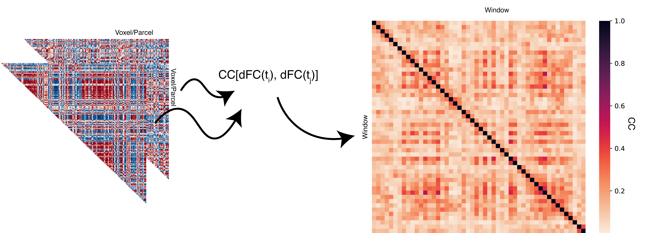

# 9 Sliding windows

import sys  
sys.path.insert(1, 'libs/')  
  
import dynfc as dyn  
import numpy as np  
from numpy.random import seed, rand  
import scipy as sc  
from scipy import io  
import seaborn as sns  
import matplotlib.pyplot as plt  
import matplotlib.cbook as cbook  
import matplotlib.cm as cm  
import matplotlib.patches as patches  
  
font = {'weight' : 'regular',  
 'size' : 24}  
plt.rc('font', **font)  
  
ts = sc.io.loadmat('data/ts.mat')['ts']  
ts = ts.transpose()  
  
corr_mats, idx = dyn.corr_slide(ts,300,50)  
  
idx.shape

> (24,)

a = [1,1,1,1,1.6]  
  
fig,ax = plt.subplots(1)  
fig.set_figheight(10)  
fig.set_figwidth(20)  
plt.style.use('tableau-colorblind10')  
for i in range(5):  
   
 plt.plot(2*i*a[i] + ts[i,]/1.4)

> [<matplotlib.lines.Line2D object at 0x7f7f9a181278>]  
> [<matplotlib.lines.Line2D object at 0x7f7f61eeacc0>]  
> [<matplotlib.lines.Line2D object at 0x7f7fbca1a0b8>]  
> [<matplotlib.lines.Line2D object at 0x7f7f9a508e80>]  
> [<matplotlib.lines.Line2D object at 0x7f7f61eeaeb8>]

plt.xlabel('Time [TRs]')

> Text(0.5, 0, 'Time [TRs]')

plt.ylabel('BOLD')

> Text(0, 0.5, 'BOLD')

ax.tick_params(left=False)  
ax.set_yticklabels([])

> [Text(0, -2.0, ''), Text(0, 0.0, ''), Text(0, 2.0, ''), Text(0, 4.0, ''), Text(0, 6.0, ''), Text(0, 8.0, ''), Text(0, 10.0, ''), Text(0, 12.0, ''), Text(0, 14.0, '')]

ax.set_ylim(-3,15.4)

> (-3.0, 15.4)

ax.set_xlim(0,1200)

> (0.0, 1200.0)

rect = patches.Rectangle((idx[0],-2.8),300,18,linewidth=4,edgecolor='#595959',facecolor='none')  
ax.add_patch(rect)

> <matplotlib.patches.Rectangle object at 0x7f7f9b33a518>

rect = patches.Rectangle((idx[5],-2.8),300,18,linewidth=4,edgecolor='#A56B6B',facecolor='none')  
ax.add_patch(rect)

> <matplotlib.patches.Rectangle object at 0x7f7f9b33a898>

rect = patches.Rectangle((idx[9],-2.8),300,18,linewidth=4,edgecolor='#CE3E3E',facecolor='none')  
ax.add_patch(rect)

> <matplotlib.patches.Rectangle object at 0x7f7f9b33aba8>

rect = patches.Rectangle((idx[16],-2.8),300,18,linewidth=4,edgecolor='#FF0000',facecolor='none')  
ax.add_patch(rect)

> <matplotlib.patches.Rectangle object at 0x7f7f9b33a668>

plt.show()



> (0.0, 200.0, 200.0, 0.0)



> (0.0, 200.0, 200.0, 0.0)



> (0.0, 200.0, 200.0, 0.0)



> (0.0, 200.0, 200.0, 0.0)



# 10 Cofluctuations

import sys  
sys.path.insert(1, 'libs/')  
  
import numpy as np  
import scipy as sc  
from scipy import io  
import dynfc as dyn  
import seaborn as sns  
import matplotlib.pyplot as plt  
  
ts = sc.io.loadmat('data/ts.mat')['ts']  
ts = ts.transpose()  
  
mat1, rss = dyn.corr_slide(ts,24)  
mat1 = mat1[:,:,0]  
  
aa = plt.figure(figsize = [6,6])  
ax = sns.heatmap(mat1,   
 cmap = "RdBu_r",   
 vmin = -1,   
 vmax = 1,   
 square = False,   
 cbar = True)  
ax.axis('off')

> (0.0, 200.0, 200.0, 0.0)

ax.tick_params(left=False, bottom=False)  
plt.show()



upt = np.triu_indices(mat1.shape[0], k = 1)  
vec = (mat1[upt])  
  
toPlot = np.zeros((vec.shape[0],1))  
toPlot[:,0] = vec  
  
aa = plt.figure(figsize = (12/50,4))  
ax = sns.heatmap(toPlot[:,0:1],   
 cmap = "RdBu_r",   
 vmin = -1,   
 vmax = 1,   
 square = False,   
 cbar = False)  
ax.axis('off')

> (0.0, 1.0, 19900.0, 0.0)

plt.show()



edges_series, corr_mats, rss = dyn.cofluct(ts, 24)  
  
aa = plt.figure(figsize = (12,4))

> /Users/runner/Library/r-miniconda/envs/r-reticulate/bin/python:1: RuntimeWarning: More than 20 figures have been opened. Figures created through the pyplot interface (`matplotlib.pyplot.figure`) are retained until explicitly closed and may consume too much memory. (To control this warning, see the rcParam `figure.max_open_warning`).

ax = sns.heatmap(edges_series,   
 cmap = "RdBu_r",   
 vmin = -1,   
 vmax = 1,   
 square = False,   
 cbar = False)  
ax.axis('off')

> (0.0, 1200.0, 19900.0, 0.0)

plt.show()



#Phase difference

import sys  
sys.path.insert(1, 'libs/')  
  
import numpy as np  
import matplotlib.pyplot as plt  
import matplotlib.patches as patches  
from mpl_toolkits.mplot3d import Axes3D  
  
theta = np.linspace(0*np.pi, 8*np.pi, 100)  
time = np.linspace(0, 8, 100)  
y1 = np.sin(theta)  
x1 = np.cos(theta)  
y2 = np.sin(theta + np.pi/2)  
x2 = np.cos(theta + np.pi/2)  
r = time/np.max(time)  
ones = np.ones(time.shape[0])  
  
fig = plt.figure()  
ax = fig.add_subplot(projection='3d')  
plt.style.use('classic')  
  
ax.plot(time, x1, y1, color = '#67001f', linewidth=2)

> [<mpl_toolkits.mplot3d.art3d.Line3D object at 0x7f808f409668>]

ax.plot(time,ones,y1, linestyle = '--', color = '#0f0f0f')

> [<mpl_toolkits.mplot3d.art3d.Line3D object at 0x7f808b0b8eb8>]

ax.plot(time,x1,-ones, linestyle = '--', color = '#0f0f0f')

> [<mpl_toolkits.mplot3d.art3d.Line3D object at 0x7f8087a49fd0>]

ax.quiver(time,0,0,0, 0.99*x1, 0.99*y1,   
 length = 0.9,   
 normalize = False,   
 arrow_length_ratio = 0.1,   
 alpha = 0.4,   
 color = '#053061')

> <mpl_toolkits.mplot3d.art3d.Line3DCollection object at 0x7f8087a49d30>

ax.text(0.5, 1, 0.5, r'$\sin(\theta)$', fontsize = 20)

> Text(0.5, 1, '$\\sin(\\theta)$')

ax.text(0.5, -1, -1, r'$\cos(\theta)$', fontsize = 20)

> Text(0.5, -1, '$\\cos(\\theta)$')

ax.set_xlabel('Time')

> Text(0.5, 0, 'Time')

ax.set_ylabel('Re')

> Text(0.5, 0, 'Re')

ax.set_zlabel('Im')

> Text(0.5, 0, 'Im')

ax.set_xlim(0,8)

> (0.0, 8.0)

ax.set_ylim(-1,1)

> (-1.0, 1.0)

ax.set_zlim(-1,1)

> (-1.0, 1.0)

plt.show()



colors1 = plt.cm.Reds(np.arange(0,1,0.01))  
colors1[:,-1] = np.arange(0,1,0.01)  
  
colors2 = plt.cm.Blues(np.arange(0,1,0.01))  
colors2[:,-1] = np.arange(0,1,0.01)  
  
fig = plt.figure(figsize = (12,8))  
ax = fig.add_subplot(projection='3d')  
plt.style.use('classic')  
  
ax.scatter(time,ones,r*y1, color = colors1, marker = ",", s = 3)

> <mpl_toolkits.mplot3d.art3d.Path3DCollection object at 0x7f808bd5d8d0>

ax.scatter(time,r*x1,-ones, color = colors1, marker = ",", s = 3)

> <mpl_toolkits.mplot3d.art3d.Path3DCollection object at 0x7f808f438780>

ax.scatter(time,ones,r*y2, color = colors2, marker = ",", s = 3)

> <mpl_toolkits.mplot3d.art3d.Path3DCollection object at 0x7f808f438940>

ax.scatter(time,r*x2,-ones, color = colors2, marker = ",", s = 3)  
#ax.plot(time,r*x2,-ones, linestyle = '--', color = colors2[-10,:])

> <mpl_toolkits.mplot3d.art3d.Path3DCollection object at 0x7f808f438438>

ax.quiver(time,0,0,0, 0.99*r*x1, 0.99*r*y1,   
 length = 0.9,   
 normalize = False,   
 arrow_length_ratio = 0.1,   
 alpha = 1,   
 color = colors1)

> <mpl_toolkits.mplot3d.art3d.Line3DCollection object at 0x7f808f438208>

ax.quiver(time,0,0,0, 0.99*r*x2, 0.99*r*y2,   
 length = 0.9,   
 normalize = False,   
 arrow_length_ratio = 0.1,   
 alpha = 1,   
 color = colors2)

> <mpl_toolkits.mplot3d.art3d.Line3DCollection object at 0x7f808f42a240>

ax.text(0.5, 1, 0.4, r'$A(t)$ $\sin(\theta)$', fontsize = 20)

> Text(0.5, 1, '$A(t)$ $\\sin(\\theta)$')

ax.text(0.5, -0.9, -1, r'$A(t)$ $\cos(\theta)$', fontsize = 20)

> Text(0.5, -0.9, '$A(t)$ $\\cos(\\theta)$')

ax.set_xlabel('Time')

> Text(0.5, 0, 'Time')

ax.set_ylabel('Re')

> Text(0.5, 0, 'Re')

ax.set_zlabel('Im')

> Text(0.5, 0, 'Im')

ax.set_xlim(0,8)

> (0.0, 8.0)

ax.set_ylim(-1,1)

> (-1.0, 1.0)

ax.set_zlim(-1,1)

> (-1.0, 1.0)

plt.show()



x1_vec = x1  
x1_vec = x1_vec[99]  
y1_vec = y1  
y1_vec = y1_vec[99]  
  
x2_vec = x2  
x2_vec = x2_vec[99]  
y2_vec = y2  
y2_vec = y2_vec[99]  
  
x, y = 0.0, 0.0  
  
fig,ax = plt.subplots(1)  
fig.set_figheight(6)  
fig.set_figwidth(7)  
ax.scatter(r*x1,r*y1, color = colors1, marker = ".", s = 100)

> <matplotlib.collections.PathCollection object at 0x7f80ff3eb4e0>

ax.scatter(r*x2,r*y2, color = colors2, marker = ".", s = 100)

> <matplotlib.collections.PathCollection object at 0x7f7f9a194c50>

ax.arrow(0,0,x1_vec,y1_vec, width = 0.015, color = colors1[-1,:], head_width = 0.1)

> <matplotlib.patches.FancyArrow object at 0x7f808f438160>

ax.arrow(0,0,x2_vec,y2_vec, width = 0.015, color = colors2[-1,:], head_width = 0.1)

> <matplotlib.patches.FancyArrow object at 0x7f7fbca0f320>

ax.add_patch(patches.Arc((x,y), 2.3, 2.3, theta1=0.0, theta2=90.0, linestyle = '--'))

> <matplotlib.patches.Arc object at 0x7f808b0caf60>

ax.text(0.7,1, r'$\mathcal{\Delta\varphi = \frac{\pi}{2}}$', fontsize = 24)

> Text(0.7, 1, '$\\mathcal{\\Delta\\varphi = \\frac{\\pi}{2}}$')

ax.text(1.18*x1_vec,y1_vec, r'$\mathcal{\varphi}_{1}$', fontsize = 20)

> Text(1.18, -9.797174393178826e-16, '$\\mathcal{\\varphi}_{1}$')

ax.text(x2_vec,1.22*y2_vec, r'$\mathcal{\varphi}_{2}$', fontsize = 20)

> Text(-7.354070601250002e-16, 1.22, '$\\mathcal{\\varphi}_{2}$')

ax.set_xlim(-1.35,1.35)

> (-1.35, 1.35)

ax.set_ylim(-1.35,1.35)

> (-1.35, 1.35)

ax.set_xlabel('Re')

> Text(0.5, 0, 'Re')

ax.set_ylabel('Im')

> Text(0, 0.5, 'Im')

plt.show()



import sys  
sys.path.insert(1, 'libs/')  
  
import numpy as np  
import scipy as sc  
from scipy import io  
import dynfc as dyn  
import seaborn as sns  
import matplotlib.pyplot as plt  
  
ts = sc.io.loadmat('data/ts.mat')['ts']  
ts = ts  
  
RSsig = np.zeros((ts.shape[0],ts.shape[1],1))  
RSsig[:,:,0] = ts  
  
Phases, syncConn, leidaArray = dyn.run_multiPat(RSsig)

> Signal filtered.  
> Phases obtained.  
> Matrices obtained.  
> Routine finished for patient no. 1.

mat1 = syncConn[:,:,0,0]  
  
aa = plt.figure(figsize = [7,6])  
ax = sns.heatmap(mat1,   
 cmap = "RdBu_r",   
 vmin = -1,   
 vmax = 1,   
 square = True,   
 cbar = True)  
ax.axis('off')

> (0.0, 200.0, 200.0, 0.0)

ax.tick_params(left=False, bottom=False)  
plt.show()



aa = plt.figure(figsize = (12/50,4))  
ax = sns.heatmap(leidaArray[:,0,]/max(abs(leidaArray[:,0,])),   
 cmap = "RdBu_r",   
 vmin = -1,   
 vmax = 1,   
 square = False,   
 cbar = False)  
ax.axis('off')

> (0.0, 1.0, 1180.0, 0.0)

plt.show()



# 11 Package References

report::cite_packages(sessionInfo())

* JJ Allaire and Yihui Xie and Jonathan McPherson and Javier Luraschi and Kevin Ushey and Aron Atkins and Hadley Wickham and Joe Cheng and Winston Chang and Richard Iannone (2020). rmarkdown: Dynamic Documents for R. R package version 2.6. URL <https://rmarkdown.rstudio.com>.
* Kevin Ushey, JJ Allaire and Yuan Tang (2021). reticulate: Interface to ‘Python’. R package version 1.18-9007. <https://github.com/rstudio/reticulate>
* R Core Team (2020). R: A language and environment for statistical computing. R Foundation for Statistical Computing, Vienna, Austria. URL <https://www.R-project.org/>.

1. King’s College London, [lucas.franca@kcl.ac.uk](mailto:lucas.franca@kcl.ac.uk)
2. King’s College London, [sunniva.fenn-moltu@kcl.ac.uk](mailto:sunniva.fenn-moltu@kcl.ac.uk)
3. King’s College London, [dafnis.batalle@kcl.ac.uk](mailto:dafnis.batalle@kcl.ac.uk)